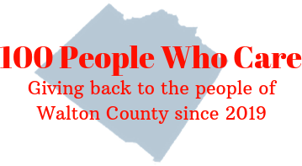
100 PEOPLE WHO CARE WALTON
Individual Registration & Commitment Form

Commitment: With my signature below, I am agreeing that the information I provide below is accurate and true. I am pledging to participate in 100 People Who Care Walton and I am making a personal commitment to contribute $200 each calendar year ($100 twice-a-year) to local nonprofit organizations serving the Walton County, Georgia region. I agree to donate twice-a-year to the nonprofit organization selected by the group’s majority vote. If I am unable to attend the meeting, I will either send my check with another attending member to deliver on my behalf, or mail it as requested after the meeting. I also acknowledge that photographs and videos taken at events and meetings may include my image and may be used in promotional materials for 100 People Who Care Walton.

I understand my personal contact information is strictly confidential and I understand it will not be shared or distributed to an outside third party without my expressed consent. If 100 People Who Care Walton chooses to publish a Membership Directory, I agree that my contact information be included in that directory. Yes____ No____

Member:
First Name Address

Last Name City State __ Zip

Best Phone Number Email Address

Date Signature

Completed Commitment Forms may be scanned and sent via e-mail to Colleen.100pwcwaltonco@gmail.com or forms maybe completed and turned in at a meeting.

If you wish to discontinue your membership at any time after your commitment, please send an email to Colleen.100pwcwaltonco@gmail.com indicating your withdrawal.

